**Assignment -3**

|  |  |
| --- | --- |
| Assignment Date | 06 OCTOBER 2022 |
| Student Name | Jagadeep J |
| Student Roll Number | 211719104048 |
| Maximum Marks | 2 Marks |

1. Create a Bucket in IBM object storage.

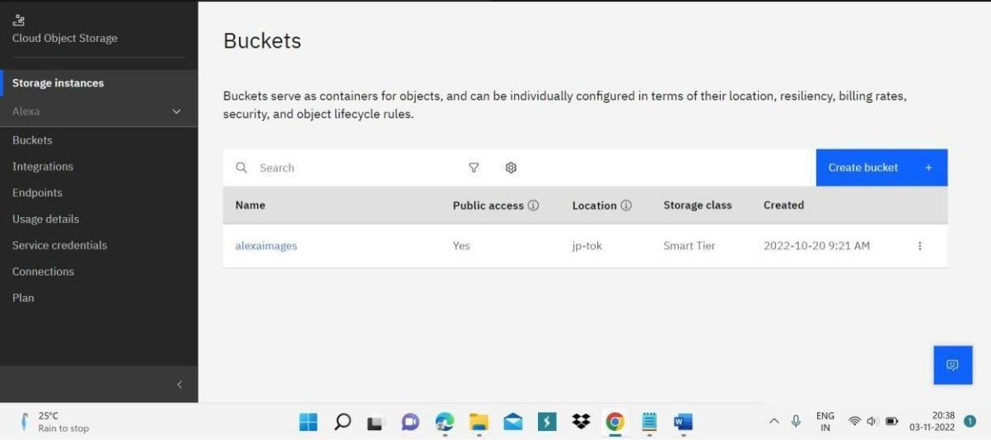

1. Upload 5 images to IBM object storage and make it public. write html code to displaying all the 5 images.

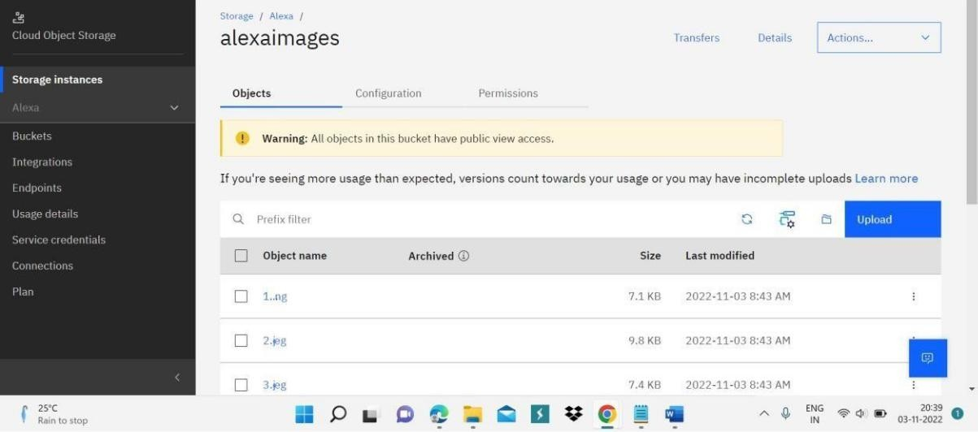

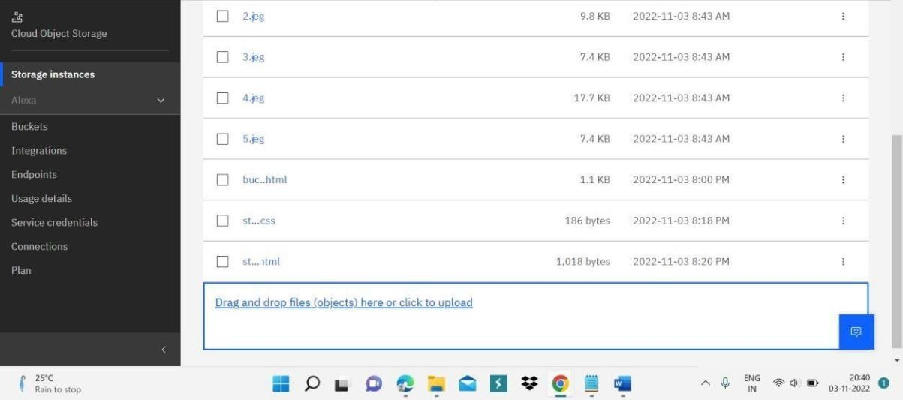

Html code:

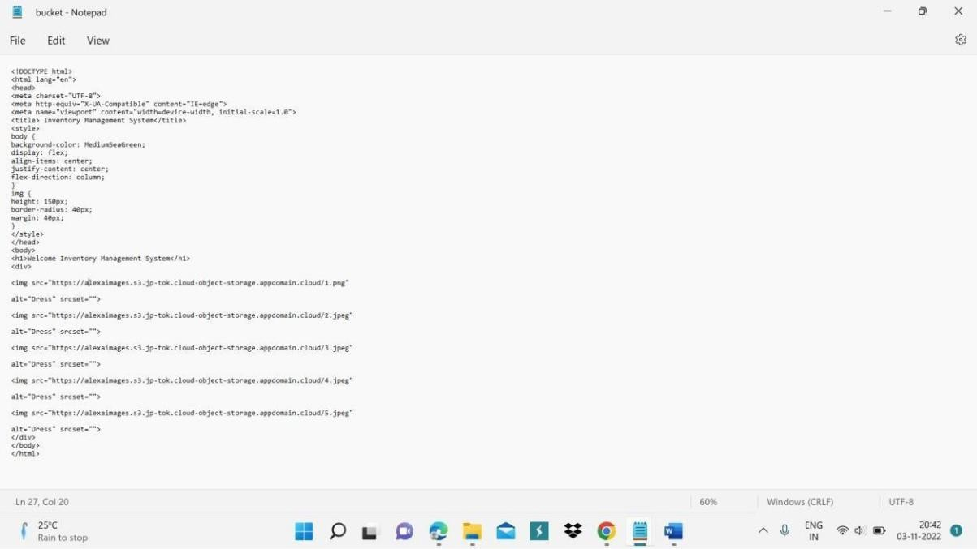

# Output:

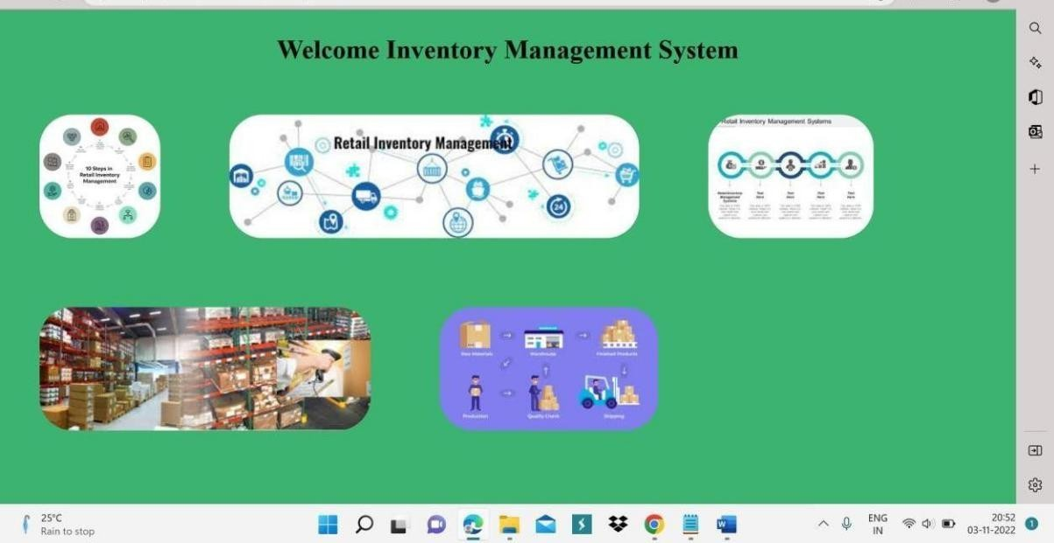

1. Upload a CSS page to the object storage and use the same page in your HTML code.

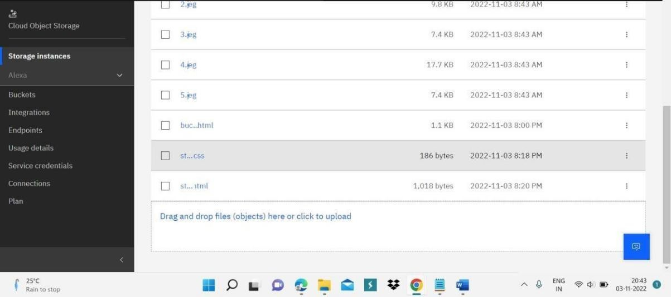

Html code:

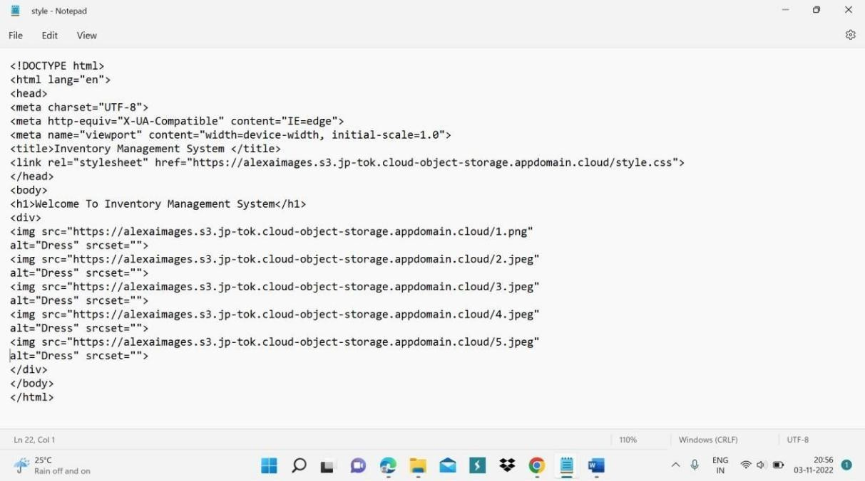

# Output:

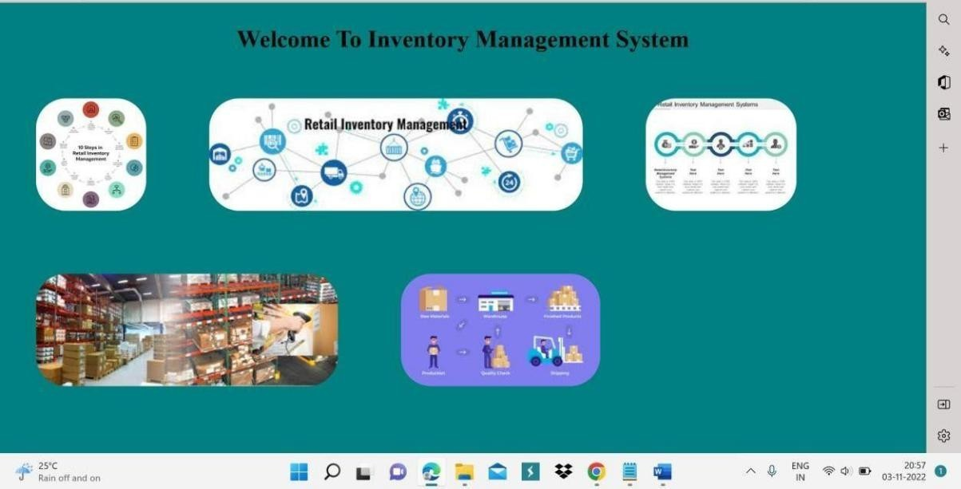

1. Design a chatbot using IBM Watson assistant for hospital. Ex: User comes with query to know the branches for that hospital in your city. Submit the web URL of that chat bot as an assignment.

https://au- syd.assistant.watson.cloud.ibm.com/crn%3Av1%3Abluemix%3Apublic%3Aco nversation%3Aau- syd%3Aa%2Fc0730717ec23417f814b6cc45740b1bd%3Ac8f677f1-8199-4002-

8f72-d193ebbbf75b%3A%3A/assistants/cd533d42-550d-43c2-9152- 0f703135f260/actions/actions/custom

https://au- syd.assistant.watson.cloud.ibm.com/crn%3Av1%3Abluemix%3Apublic%3Aco nversation%3Aau- syd%3Aa%2Fc0730717ec23417f814b6cc45740b1bd%3Ac8f677f1-8199-4002-

8f72-d193ebbbf75b%3A%3A/assistants/cd533d42-550d-43c2-9152-

0f703135f260/actions/actions/custom/edit/action_3978

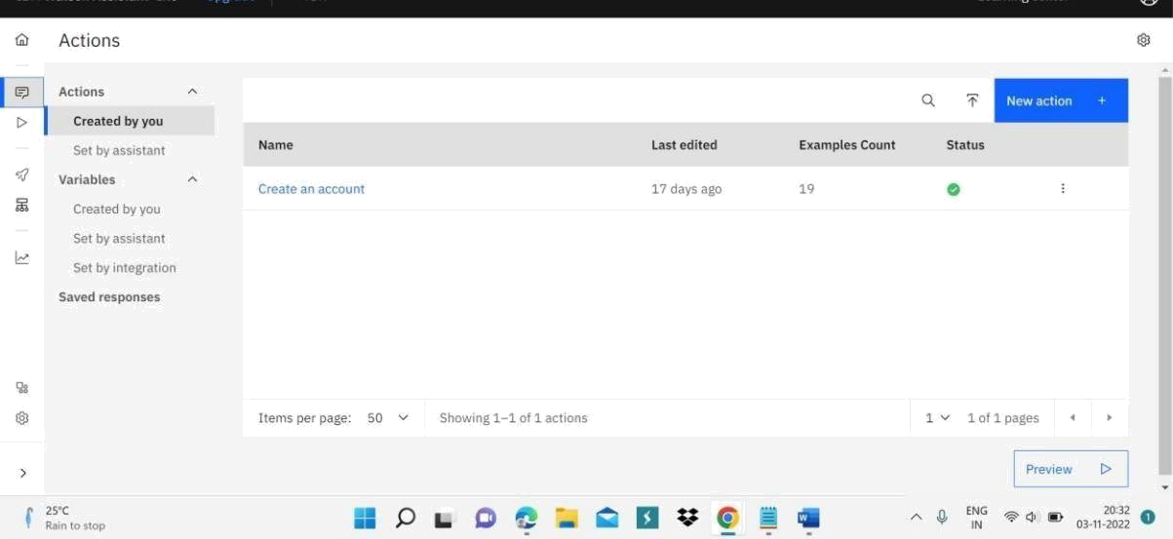

1. Create Watson assistant service with 10 steps and use 3 conditions in it. Load that script in HTML page.

Html page:

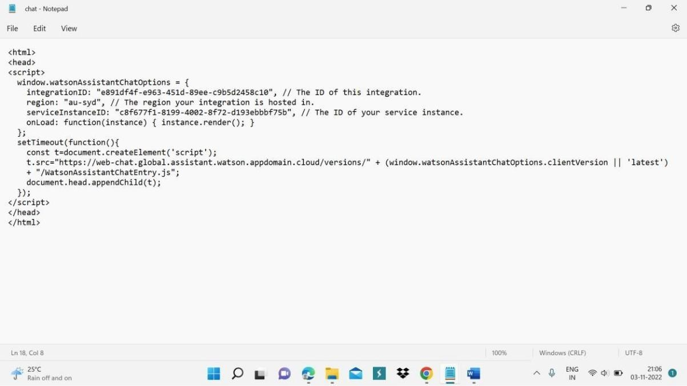

Output:

